Networking Training
Allen Paul - Assignment
Module 1 and 2:

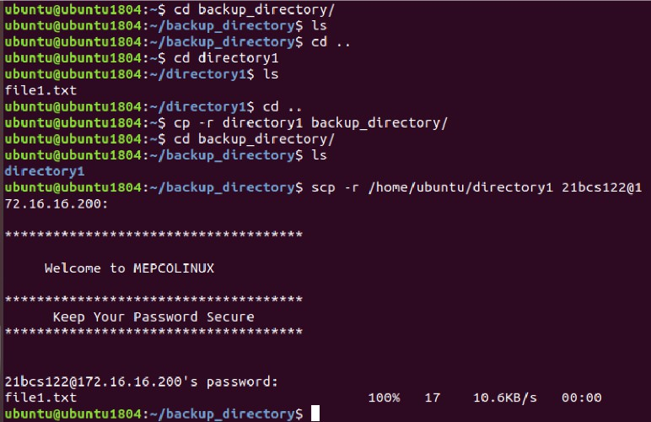
Problem 1:

Problem 2:
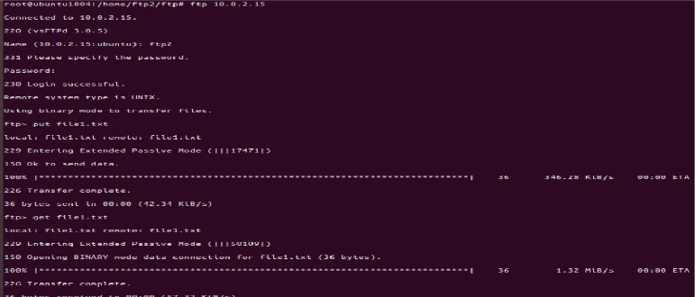

Problem 3:
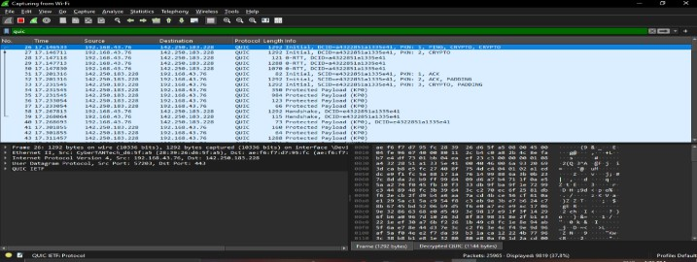

Problem 4:
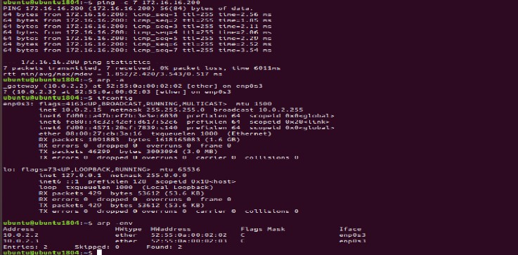

Problem 5:
When two devices have same ip, the arp cache will be corrupted with incorrect MAC to IP mapping. This is because, same ip claimed by different devices leading to packet directed to wrong devices with same ip. This will cause connectivity issues due to error messages and retransmissions.

Problem 6:
- Install AnyDesk on both devices. Use the AnyDesk address given by the remote computer to request remote connection. The request must be accepted, or simply set password for access.

- Enable remote desktop in settings of remote computer. Install remote desktop client on your computer. Using the name of remote computer connect remotely. Enter username and password of access of remote computer.

Problem 7:
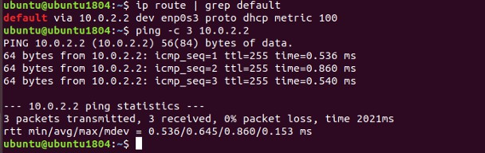

Problem 8:
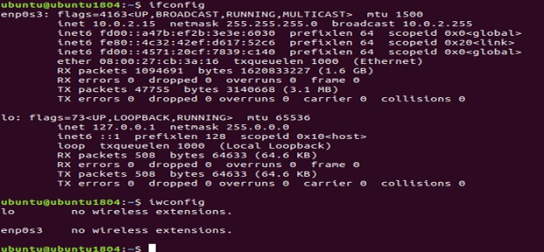

Problem 9:

- Launch a web browser on your device.
- Enter the router’s IP address in the address bar, typically:
- Log in using the administrator username and password.
- Navigate to the section labeled "Connected Devices," "Device List," or "LAN Status." 5. Here, you’ll find a list of all devices currently linked to your network via Wi-Fi or Ethernet.

Problem 10:

DORA process:
Discovery: The device attempting to join the network sends out a broadcast message to request an IP address.
Offer: A DHCP server responds with an offer, providing an available IP address from its pool. Request: The device sends a request back to the DHCP server, asking to use the offered IP address.
Acknowledgment: The DHCP server confirms and assigns the IP address to the device for a specified duration

Problem 11:
